



501 Court St

Beatrice NE, 68310

Phone: 402-223-3591

Clabaugh

Pharmacy

NEWSLETTER

Your Hometown, Family Pharmacy

May 2022 Vol 19 Issue 5

u

**What’s New at the Pharmacy:**

2nd COVID-19 BOOSTERS

We are now administering the 2nd Booster of Moderna and Pfizer for those who qualify. You must be 50 years of age or older and have had at least 4 months since your last booster.

At Clabaugh Pharmacy we strive to make sure our customer service is what sets us apart from other pharmacies. Clabaugh Pharmacy IS Your Hometown Family Pharmacy, where patients come first! We know you have options when choosing your phramcy and take pride in customer needs and satisfaction. You will feel the difference when you walk through our doors. There are numerous services we offer to our community and we aim to go above and beyond for our patients. Here are a few of our services that we offer here at Clabaugh Pharmacy….

* Our sync program – we fill all of your prescriptions at once, monthly. We contact your doctor for any refills you need and have your medications ordered and ready for pick-up, delivery, or mail! On your monthly date.
* Immunizations - we offer numerous immunizations.
* Convenient drive-thru for your prescriptions or over the counter items you may need! Call ahead and we’ll have your items waiting for you to pick up!
* Delivery or mailing options! (FREE WHEN YOU SIGN UP FOR OUR SYNC PROGRAM)
* Several options for medication packaging
* Unused medication disposal box (free)

Pharmacist

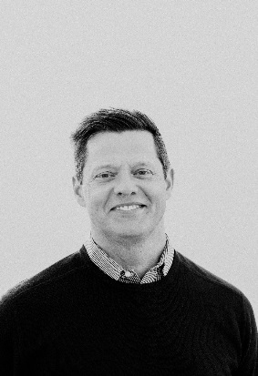

Nathan Clabaugh, PharmD., R.P.

May Tidbits

Birthstone is Emerald

Flower is Lily of the valley AND Hawthorn

Zodiac signs are Taurus April 21- May 20 and Gemini May 21- June 21.

**Quotes**

**“Yesterday I was clever, so I wanted to change the world. Today I am wise, so I am changing myself.”  
― Rumi**

**Be the change that you wish to see in the world.”  
― Mahatma Gandhi**

**Health Corner**

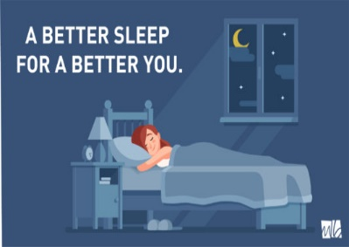**Protect Your Health with Better Sleep**

With all the talk about coronavirus in the world, we want to emphasize something that is one of the most practical and important things you can do to stay healthy now and, in the future, get proper sleep. Here are some tips to consider if you find yourself having a hard time sleeping well.

To get better sleep, it is important to start a relaxing bedtime routine. You can start by deciding to go to bed and get up in the morning at about the same time every day, even on weekends. A good schedule might be to be in bed by 10:30pm and arise by 6:30am. That’ll give you a full eight-hours of sleep, and you’ll sleep better on a routine like this. Additional ideas for a better sleep include:

1. Choose a comfortable mattress and pillow.
2. Avoid nicotine, alcohol and caffeine in the evening.
3. Exercise regularly, and at a time right for you.
4. Keep your bedroom quiet, dark and comfortable. Keep work materials, computers and televisions out of the bedroom.
5. Avoid discussing emotional issues in bed.
6. Avoid napping.
7. Keep pets off the bed.
8. Don't eat or drink large amounts before bedtime. Eat right, sleep tight.
9. Use sleeping pills only as a last resort.



**Thank You!**

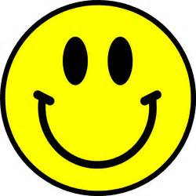

Thanks to YOU the word is spreading! Thanks to all of our wonderful customers and friends who graciously referred us to their friends and neighbors last month!

Our business runs on positive comments and referrals from people just like you! We couldn’t do it without you!

**In Pop Culture History**

**On this day……**

May 1—2011 Osama bin Laden was reported killed by U.S. forces in Pakistan.

May 2—1965 The Rolling Stones made their second appearance on the Ed Sullivan Show.

May 3—1991 The final episode of Dallas was broadcast on CBS,

May 4—1886 A labor protest in Haymarket Square in Chicago, Ill. Resulted in 10 wounded and 8 police officers killed.

May 5—1862 General Ignacio Zaragoza defeated a French army led by General Charles Larille de Lorencez that was attempting to capture Puebla de Los Angeles, a small town in east-central Mexico. This was the initial Cinco de Mayo cause for celebration.

May 6—1937 The Hindenburg exploded over Lakehurst, New Jersey. Killing 36 passengers and crewmembers.

May 7—1896 Dr. H.H Holmes, one of America’s 1st well-known serial killers, was hanged to death in Philadelphia, Pennsylvania. Over 2500 bodies were found on his property.

May 8—1963 Dr. No, starring Sean Connery, opened in theaters.

May 9—1992 The Golden Girls aired their series finale.

May10—1924 J. Edgar Hoover was named acting director of the bureau of Investigation (now the FBI).

May 11—1980 Bob Marley died from lung cancer, 1997 IBM’s super -computer Deep Blue defeated chess champion Garry Kasparov.

May 12—1993 The Wonder Years television series came to an end.

May 13—1981 Pope John Paul !! was shot by Mehmet Ali Agca.

May 14—1804 Lewis and Clark expedition left St. Louis, Missouri, on a mission to explore the Northwest from the Mississippi to the Pacific Ocean.

May 15—1862 President Abraham Lincoln signed a bill into law creating the US Bureau of Ag. It was later renamed the US Dept. of Ag.

May 16—1996 12 million people turned in for the series finale of Murder She wrote on CBS.

May 17—1792 The New York Stock Exchange was formed.

May 18—1998 Murphy Brown TV series ended on CBS.

May 19—1997 Avian flu, A(HSN1) killed a 3-year-old boy in Hong Kong, its 1st victim.

May 20—1994 The Joan Rivers Show came to an end.

May 21—1975 Carol Burnett was added to the Hollywood Walk of Fame.

May 22—1992 Johnny Carson hosted The Tonight Show for the last time.

May 23—1934 Bank robbers Bonnie and Clyde were shot to death near Bienville Parish, Louisiana.

May 24—1883 The Brooklyn Bridge over the East River opened, connecting Manhattan and Brooklyn.

May 25—1935 At Forbes Field in Pittsburg, Pennsylvania, Babe Ruth hit his 714th and final home run.

May 26—1977 George Willig illegally climbed the South Tower of New York City’s World Trade Center.

May 27—1994 The Arsenio Hall Show came to an end on Fox.

May 28—1999 In Milan, Italy, after 22 years of restoration work, Leonardo da Vinci’s masterpiece The Last Supper was put back on display. It was bigger than most people think… almost 29 feet wide.

May 29—1979 Actor Woody Harrelson’s father, Charles Harrelson, was charged with the murder of Judge John Wood.

May 30—1966 Launch of Surveyor 1, the first US spacecraft to land on the moon.

May 31—2000 Survivor premiered on CBS